1. **Assembler operation**

Asembly language

1. Easiest programming language : the opcodes are replaced with symbolic names
2. Represents the specific programming language for each computer, being in a close relationship with the processor.
3. Allow the memory storage elements(bytes,words) to be identified by names

**Assembler**

* Transforms a program written in assembly language into a program written in machine code
* Purpose -> associate numeric values to symbols

->Create the program written in machine code

Translating the Source Program – 2 passes

Pass 1:

1. Read the source program

1. Fit in the symbol table( by associating the found symbols with the numeric values corresponding to the CLC, which shows the effect from the beginning of the progrm)  
   CLC=current location counter

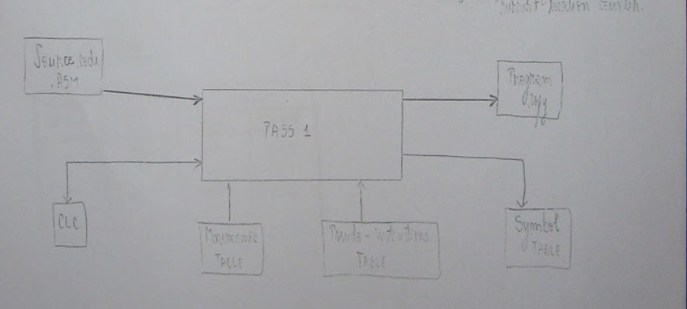

Pass 2:

1.read again the initial program

2. based on the symbol table, the object program is generated

Object program = a file containing the program in binary form

* Contains the instruction opcodes
* Not executable

3. Optionally , the source program list, object assembly errors are also generated

